**REAL TIME OBJECT MEASUREMENT in Images using SVM (Support Vector Machine)**

**Title-1**

Improved accuracy in real time object measurement using Support Vector Machine in comparison with SSD (Single Short Multi box Detector) algorithm.

**PICO:**

Problem: Less accuracy in real time object measurement

Intervention: Support Vector Machine

Comparison: Single Short Multi box Detector

Outcome: Improved accuracy

**Title-2**

Improved accuracy in real time object measurement using Support Vector Machine in comparison with Random forest algorithm.

**PICO:**

Problem: Less accuracy in real time object measurement

Intervention: Support Vector Machine

Comparison: Random forest algorithm

Outcome: Improved accuracy

**Title-3**

Improved accuracy in real time object measurement using Support Vector Machine in comparison with EfficientDet algorithm.

**PICO:**

Problem: Less accuracy in real time object measurement

Intervention: Support Vector Machine

Comparison: EfficientDet algorithm.

Outcome: Improved accuracy

**Title-4**

Improved accuracy in real time object measurement using Support Vector Machine in comparison with mask RCNN algorithm.

**PICO:**

Problem: Less accuracy in real time object measurement

Intervention: Support Vector Machine

Comparison: Mask RCNN algorithm

outcome: Improved accuracy.

**TABLE:**

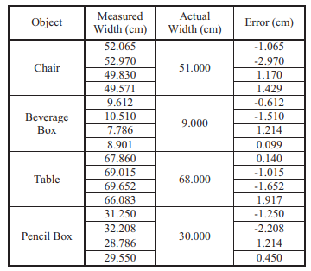

**Sample size:**

